#### 

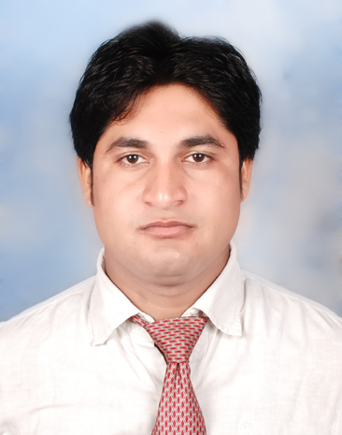

#### RAHUL KUMAR GUPTA

**+919990268584**

[**rahul47giit@gmail.com**](mailto:rahul47giit@gmail.com)

**CAREER OBJECTIVE**

### *Working in a professional environment with committed and dedicated people where I can get the opportunity to expand my field of Knowledge for professional as well as personal growth*

**ACADEMIC RECORD**

|  |  |  |  |  |
| --- | --- | --- | --- | --- |
| **DEGREE** | **INSTITUTION** | **UNIVERSITY/BOARD** | **YEAR** | **PERCENTAGE** |
| **MBA** | Accurate Institute of Advanced Management  (Greater Noida) | Mahamaya Technical University | 2013 | 70.41 |
| **B.C.A.** | Global Institute Of Information Technology  (Greater Noida) | Choudhary Charan Singh University | 2011 | 67.76 |
| **12th** | C.R.T.S.V.M | U.P. BOARD | 2008 | 72.60 |
| **10th** | C.R.T.S.V.M | U.P. BOARD | 2006 | 66.50 |

**SEMINARS / WORKSHOPS ATTENDED**

1:-**NSIC**- (National Small Scale Corporation) 2:-**NSE**-(National Stock Exchange)

3:-**SEBI**-(Security Exchange Board of India)

**ACHIEVEMENTS**

* Tehsil level science competition winner,2nd Rank in 2004
* School level G.K. competition winner,1st Rank in 2005
* Class representative in BCA

**SUMMER INTERNSHIP**

* (“Supply Chain Management In L.G. electronics”)
* Company: L.G. electonics (greater noida)
* Duration: 45 days(Summer Training)
* Period: June 1st to 21st July , 2012

**WORK EXPERIENCE**

1. **Assistant Manager at ATN INFRATECH PVT. LTD (8 MONTH) From 1st March 2013 to 31st Oct 2013.**

**Key Responsibility**

* Deals in all type of residential and commercial flats.
* New clients orientation for company
* Deal closures on leads
* Revenue basis sales

1. **Assistant Manager at Kotak Mahindra Bank from 23 Nov 2013 to till date**.

**Key Responsibility**

* Acquire value in sourced NTB account
* Acquire term deposit from NTB sourced account and from open market
* Selling investment products
* Cross sell of Asset products, Creditcard, General insurance, Dmat, mutual funds and trading account.
* Increase customer stickiness and wallet share with the Bank by offering bundled/multiple products.
* Making Customer profiling and properly follow all KYC norms.
* NTB Saving and current account sourcing from open market.

**AREA OF INTEREST**

* Marketing.
* Organization Behavior.
* Computer Fundamental.

**TECHNICAL SKILLS**

* MS OFFICE
* Internet
* Windows Vista and Windows 7 & windows 8

**HOBBIES**

* Cooking
* Tourism
* Cricket
* Listening Songs

**EXTRACURRICULAR ACTIVITIES**

* Cricket captain of school team
* Active Particiaption in School & College level cultural programs
* Participation in Group discusson,Role play & debate

**PERSONAL VITAE**

Date of Birth : 23 April 1992

Father’s name : Mr. Sudarshan Lal Gupta

Gender : Male

Address : J-37, Beta-2nd, Greater Noida

Marital status : Unmarried

Nationality : Indian

Languages : English, & Hindi

Declaration:

I hereby solemnly affirm that all the details provided above are true to the best of my knowledge.

Date ……………..

Place Signature